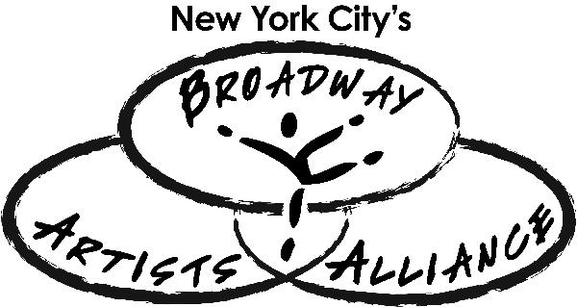
SAMPLE Schedule for the
College Audition Prep Seminar

DAY ONE
9:30AM-10:00AM Students arrive at Ripley Grier Studios to check in and begin orientation
10:00AM-11:00AM Orientation
11:00AM-12:30PM Group discussion about various performing arts programs
12:30PM-2:00PM Monologue/Song Selection Masterclass
2:00PM-2:30PM Lunch
2:30PM-6:00PM College Audition Technique Master Class
6:00PM-6:30PM Re-cap, student assignments for Day Two
6:30PM Day One concludes

DAY TWO
9:30AM-10:00AM Students arrive at Ripley Grier Studios to check in
10:00AM-12:30PM Group discussion about the college audition process and choosing the program that’s right for you
12:30PM-2:00PM Repertoire Workshop
2:00PM-2:30PM Lunch
2:30-4:00PM College Audition Dance Call Master Class
4:00PM-7:00PM Repertoire Workshop and individual coaching sessions
5:30PM-7:00PM College Financial Aid Master Class FOR PARENTS (optional but recommended)
7:00PM Day Two concludes

DAY THREE
9:30AM-10:00AM Students arrive at Ripley Grier Studios to check in and begin orientation
10:00AM-11:00AM Prescreen video audition, essay, and resume Bootcamp
11:00AM-1:00PM Final Repertoire Workshop and individual coaching sessions
1:00-1:30PM Lunch and Mock Audition Prep
2:00PM-4:30PM Mock Auditions
4:30PM -6:30PM Exit Interviews and Evaluations
6:30PM-7:00PM Group photo and farewells! Parents pick up students onsite.

