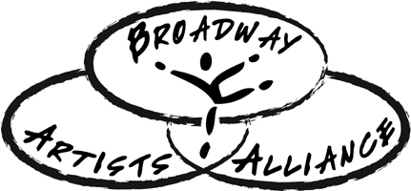

Coming home all the way from Broadway!
[Your Name] has just finished a Summer with Broadway Artists Alliance in New York City!
[ADD INFO ABOUT STUDENT AND THEIR SESSION]
[Your Name] has had an amazing time with Broadway Artists Alliance in New York City! This past week [he/she] studied [Class Name #1] with [Teacher Name], [Class Name #2] with [Teacher Name], and much more. [He/she] also got the chance to watch the Broadway show [Broadway Show Name] and [he/she] met with the cast for a talkback discussion after the show! [Your Name] and [his/her] classmates had a special visit from Tony Winner, Gavin Creel from Hello, Dolly during their time at Broadway Artists Alliance, as well as Tony Nominee Laura Osnes from Bandstand. [Your Name] ended the week performing in a final showcase for top industry professionals from New York City. Happy trails to you!

Broadway Artists Alliance of New York City is an elite, audition-based program that provides professional training for young musical theatre performers. The program is uniquely situated in the heart of New York City, and offers classes taught by Tony Award winners, Broadway performers and New York’s top casting directors, agents, coaches and choreographers. Candidates audition to be voice, acting, or dance majors and, if accepted, get to study in New York City with other students from around the country and overseas.
Broadway Artists Alliance students work to develop their “Triple Threat” performance skills while learning about the business of acting and making connections with industry professionals. They also perform in a final industry showcase for top NYC Agents, Managers and Casting Directors.
Students receive group instruction and private coaching in disciplines including audition technique, song interpretation, monologue work, scene study, on-camera acting, and musical theatre dance from instructors including Tony Award Winners Lin-Manuel Miranda, Renee Elise Goldsberry, Sutton Foster, Jessie Mueller and Christian Borle, and Broadway and TV professionals as Jeremy Jordan, Lea Michele, Megan Hilty, Aaron Tveit and more!
Broadway Artists Alliance’s alumni students can be seen on Broadway, in National Tours, on Television, and in Film. Past students include Grammy Nominee Ariana Grande, Broadway’s Kyle Taylor Parker (Kinky Boots, Charlie and the Chocolate Factory), Clay Thomson (Newsies, Matilda), and Emma Howard (Matilda, Violet and The Beguiled film). BAA Alumni currently on Broadway include Nala Hamilton, Zach Thomas, and Rika Nishikawa (The Lion King), Ryan Foust (Charlie and The Chocolate Factory), Sammy Bray (1984) and Hillary Porter (A Bronx Tale)!

To learn more about what [Your Name] experienced with Broadway Artists Alliance, and how you can also be a part of the experience, visit our website at www.broadwayartistsalliance.org, or contact us via social media through @BAAofNYC in Instagram and Twitter, and on Facebook at fb.me/BroadwayArtistsAlliance.

